INDEXU 7
How to translate into different languages

By Dody Rachmat W. (dodyrw@gmail.com)
August 27, 2011

Unlike earlier version, Indexu 7 use its own language engine. Gettext has been removed as we are looking for something easier to manage and avoiding incompatibility issue.

Now we use a a simple plain text language file. The language file is located at

/language/default.po

In this tutorial we will learn :
- Replacing text in php files
- Working faster with file text parser
- Working faster with google translate
- Replacing text in database

Replacing text in php files

Now lets take a case. We are going to translate the “Directory Statistic” widget.
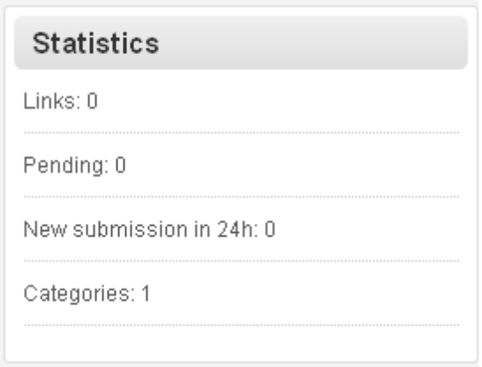

The corresponding file for this widget is located at :

/templates/komet/widget/dir_stat.php

The following codes are taken from dir_stat.php

<ul>
<li><?php print _t("Links"); ?>: <?php print $active_links; ?></li>
<li><?php print _t("Pending"); ?>: <?php print $pending_links; ?></li>
<li><?php print _t("New submission in 24h"); ?>: <?php print $last_24h_links; ?></li>
<li><?php print _t("Categories"); ?>: <?php print $categories; ?></li>
</ul>

To make the text become translatable, it must be put inside _t() function.

Now open default.po file, add the following lines to translate into Indonesian:

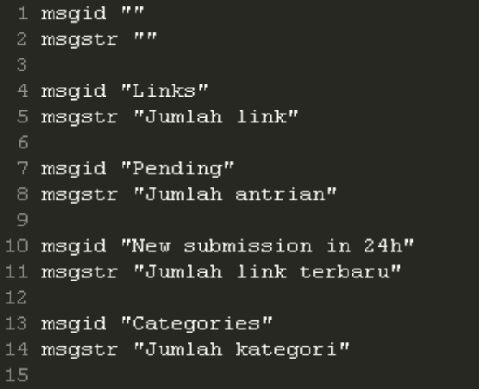

Reload indexu page to see the result.

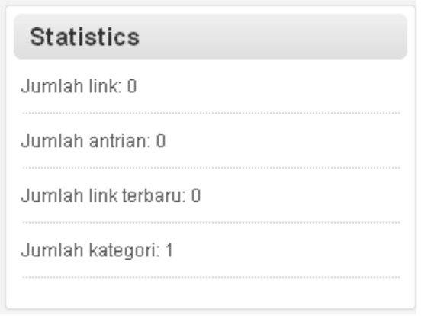

Lets try again for different language. Here is for Spanish translation.

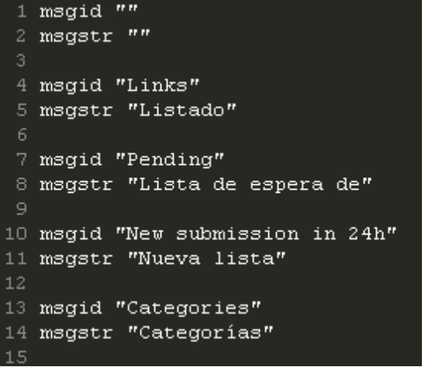
Result :

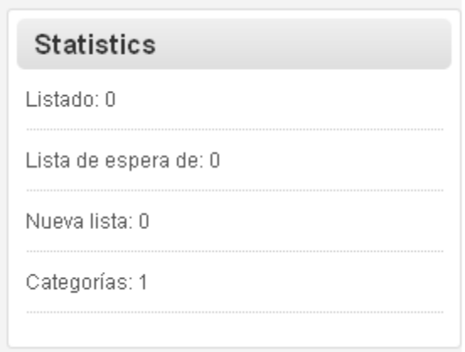

Now you should have a good understanding the basic concept of how Indexu 7 template engine work.

Working faster with file text parser

Instead of working manually one by one putting replaceable text to default.po file, in this section we are going to use gettext command line tool to do the job all at once. You will need a linux box or mac osx with gettext module installed.

Go to templates folder
$ cd templates

Run the following command to parse all replaceable text.
$ find . -iname "*.php" | xargs xgettext --keyword=_t --no-location

It will generate a new file called messages.po. Rename it to default.po.

Use this file as starting point to translate. Start with filling msgstr value.

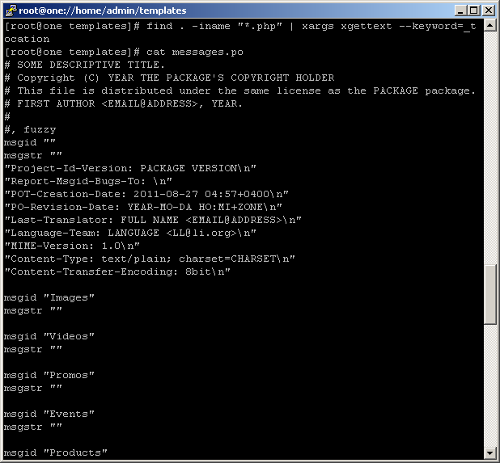

Working faster with google translate

I come up with the idea of using google translate to speed up the translation process. Since we use gettext .po file, I look for a ready made tools for translating po file using google translate. Use google keyword “translate po file with google translate” to find these kind of tools.
The one I prefer is http://translate.umpirsky.com.
Here is how the workaround :
- Open the website.
- Copy paste code from default.po file to the textarea form.
- Select the language.
- Put check mark on Overwrite existing translation
- Hit translate button.
- Wait until the process completed, then copy and paste the result to default.po file.

Google translate is not 100% accurate. But I think the result is quite good. It help a quick start translation process. What we need to do is to proofread the result.

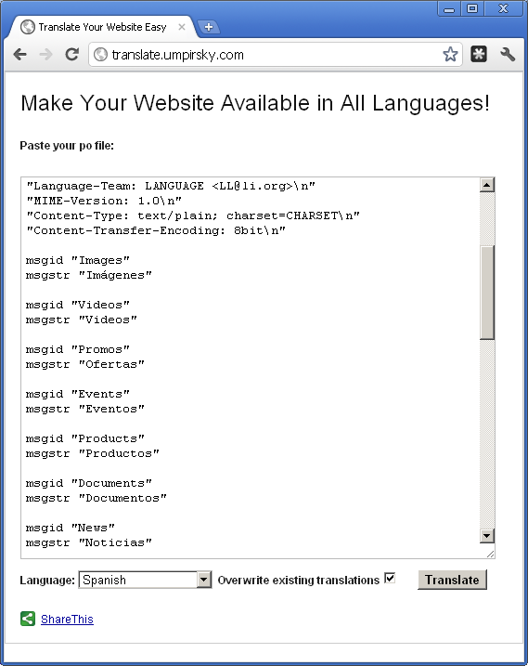

Replacing text in database

With new language engine, it is now possible to make translation from database. Here is what kind of data that can be translated :
- page detail
- widget title
- static page title and content
- menu
- links
- custom field detail

To generate the translation text, run extra_lang.php from browser.
http://www.domain.com/extra_lang.php
For security reason, you must login as admin.

The script will generate a text file. Add the text from this file to default.po file you already have from previous steps.
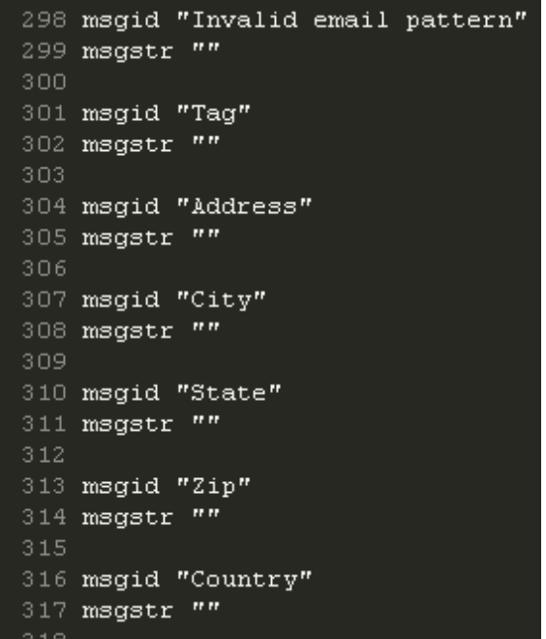
You may want to run google translate tool once more. Right now you should have a complete set of replaceable text.

